#1

#2

#3

#4

#5

#6

#7

#8

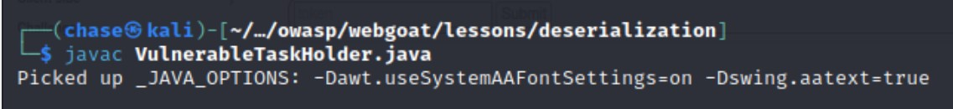

#9

#10

This is where I failed. I tried to work on my code but it would not compile.

#11

Did not complete. I tried to troubleshoot but in the end could not. My apologies Professor. I will complete the other labs to their entirety, I just got stuck on the last part compiling the Attack code and using the exploit.